1. **ARDUINO NANO**

**2.1 GENERAL:**

The Arduino Nano is a small Arduino board based on ATmega328P or ATmega628 Microcontroller. The connectivity is the same as the [Arduino UNO board](https://www.javatpoint.com/arduino-uno).

The Nano board is defined as a sustainable, small, consistent, and flexible [microcontroller](https://www.javatpoint.com/microcontroller) board. It is small in size compared to the UNO board. The Arduino Nano is organized using the Arduino (IDE), which can run on various platforms. Here, IDE stands for Integrated Development Environment.

The Arduino Nano is equipped with 30 male [I/O](https://en.wikipedia.org/wiki/I/O) headers, in a [DIP-30](https://en.wikipedia.org/wiki/Dual_in-line_package)-like configuration, which can be programmed using the [Arduino](https://en.wikipedia.org/wiki/Arduino) Software [integrated development environment](https://en.wikipedia.org/wiki/Integrated_development_environment) (IDE), which is common to all Arduino boards and running both online and offline. The board can be powered through a [type-B mini-USB](https://en.wikipedia.org/wiki/USB_hardware#Connectors) cable or from a 9 V battery

The devices required to start our projects using the Arduino Nano board are [Arduino IDE](https://www.javatpoint.com/arduino-ide) and mini [USB](https://www.javatpoint.com/arduino-uno). The Arduino IDE software must be installed on our respected laptop or desktop. The mini USB transfers the code from the computer to the Arduino Nano board.

**2.2 HISTORY OF ARDUINO NANO**

The Arduino Nano was released in 2008. In 2019, Arduino released the Arduino Nano Every, a pin-equivalent evolution of the Nano. It features a more powerful ATmega4809 processor and twice the RAM.

The [Arduino](https://www.javatpoint.com/arduino) Nano is shown below:

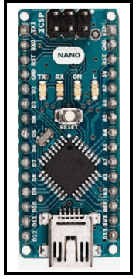

**2.3 WHY IS ARDUINO NANO USED?**

* Using the constant voltage, the Arduino Nano is used to produce a clock of a precise frequency.
* The Arduino Nano has a compact size and mini USB cable than the Arduino UNO. We can use Nano instead of UNO because both operate on the microcontroller ATmega328p.
* The Arduino UNO is also easily available than Nano. It is considered as the standard board available in the market, which is easy for use for the starters or beginners.
* The Nano is available in PDIP (Plastic Dual - Inline Package), while Arduino UNO is available in TQFP (Plastic Quad Flat Pack).
* The Arduino UNO includes 6 analog pin inputs, 14 digital pins, a USB connector, a power jack, and an ICSP (In-Circuit Serial Programming) header. The Arduino Nano includes an I/O pin set of 14 digital pins and 8 analog pins. It also includes 6 Power pins and 2 Reset pins.

**2.4 MEMORY**

The memory in Arduino Nano is shown in the below image:

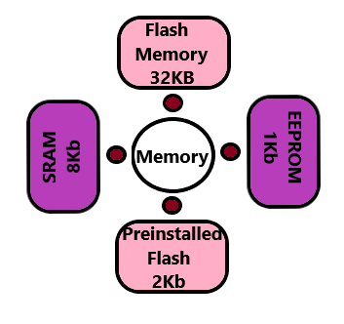

The preinstalled flash has a boot loader, which takes the memory of 2Kb.

**2.5 TECHNICAL SPECIFICATIONS**

[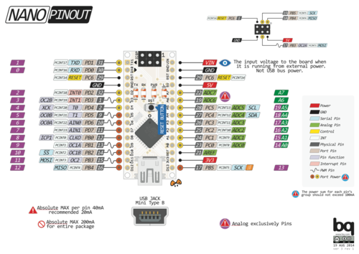](https://en.wikipedia.org/wiki/File:Arduino-nano-pinout.png)

The technical specifications of the Arduino Nano board are:

* The operating voltage of the Nano board varies from 5V to 12V.
* The total pins in Nano are 22 Input/Output pins.
* There are 14 digital pins and 8 analog pins.
* There are 6 PWM (Pulse Width Modulation) pins among the 14 digital pins. The 6 PWM pins in Arduino Nano are used to convert the digital signals into the analog signals. The conversion takes place by varying the width of the pulse.
* The crystal oscillator present in Arduino Nano comes with a frequency of 16MHz.
* The Arduino Nano is used in various applications such as Robotics, Control System, Instrumentation, Automations, and Embedded Systems.
* The projects created using Arduino Nano are QR Code Scanner, DIY Arduino Pedometer, etc.
* We can also connect Arduino Nano to the WiFi.
* The functionality of Nano is similar to the Arduino UNO.
* The flexibility and eco-friendly nature of Nano make it a unique choice to create electronic devices and projects with compact size.

**2.6 COMMUNICATION**

The Arduino Nano has a number of facilities for communicating with a computer, another Arduino, or other microcontrollers. The ATmega328 provides UART TTL (5V) serial communication, which is available on digital pins 0 (RX) and 1 (TX).

An FTDI FT232RL on the board channels this serial communication over USB and the FTDI drivers (included with the Arduino firmware) provide a virtual com port to software on the computer. The Arduino software includes a serial monitor which allows simple textual data to be sent to and from the Arduino board. The RX and TX LEDs on the board flash when data is being transmitted via the FTDI chip and the USB connection to the computer (but not for serial communication on pins 0 and 1). A Software Serial library allows for serial communication on any of the Nano's digital pins. The ATmega328 also supports I2C and SPI communication. The Arduino software includes the Wire library to simplify use of the I2C bus.

Rather than requiring a physical press of the reset button before an upload, the Arduino Nano is designed in a way that allows it to be reset by software running on a connected computer. One of the hardware flow control lines (DTR) of the FT232RL is connected to the reset line of the ATmega328 via a 100 Nano farad capacitor. When this line is asserted (taken low), the reset line drops long enough to reset the chip.[[4]](https://en.wikipedia.org/wiki/Arduino_Nano#cite_note-website-4)

This setup has other implications. When the Nano is connected to a computer running Mac OS X or Linux, it resets each time a connection is made to it from software (via USB). For the following half-second or so, the bootloader is running on the Nano. While it is programmed to ignore malformed data (i.e. anything besides an upload of new code), it will intercept the first few bytes of data sent to the board after a connection is opened.

**2.7 HOW TO GET STARTED WITH ARDUINO NANO?**

We can program the Arduino Nano using the Arduino IDE.

We can also use Arduino Web Editor, which allows us to upload sketches and write the code from our web browser (Google Chrome recommended) to any Arduino Board. It is an online platform.

The steps to get started with Arduino Nano are listed below:

* Open the code or sketch written in the Arduino software.
* Select the port and the type of board.
* The ATmega328p microcontroller is used in the Arduino Nano. So, we will select the Processor as ATmega328p.
* Click on 'Tools' and select Processor, as shown below:

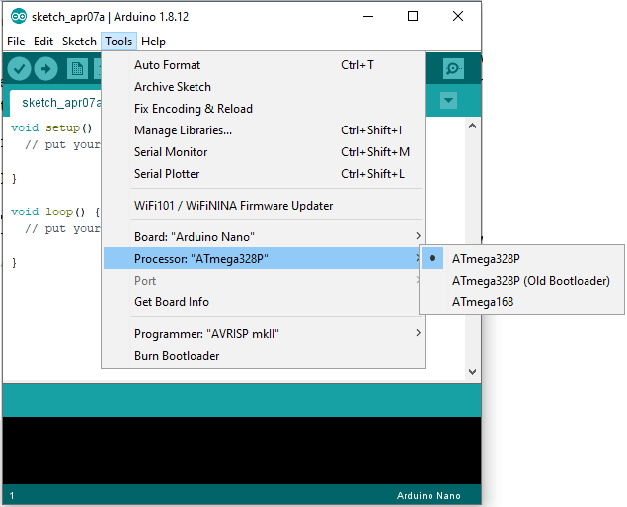

* Now, upload and run the written code or sketch.
* To upload and run, click on the button present on the top panel of the Arduino display, as shown below:

Arduino Nano

* Within the few seconds after the compile and run of code or sketch, the RX and TX light present on the Arduino board will flash.
* The 'Done Uploading' message will appear after the code is successfully uploaded. The message will be visible in the status bar.